Linux - Unix Shell Programming Lab Programs —---------------------------------------------------------------------------------------------

A1. Implement a shell program to find and display largest and smallest of three numbers

A1.LargestSmallest.sh

#!/bin/sh
echo "Please enter the 3 numbers"
read x
read y
read z

if [ $x -ge $y ] && [ $x -ge $z ]
then
echo "$x is the largest number"
elif [ $y -ge $x ] && [ $y -ge $z ]
then
echo "$y is the largest number"
else
echo "$z is the largest number"
fi

if [ $x -lt $y ] && [ $x -lt $z ]
then
echo "$x is the smallest number"
elif [ $y -lt $x ] && [ $y -lt $z ]
then
echo "$y is the smallest number"
else
echo "$z is the smallest number"
fi

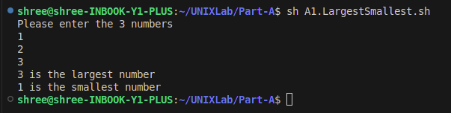
A2. Find the number n is divisible by m or not using shell script. Where m and n are supplied as command line argument or read from key board interactively

lab2a.sh

#!/bin/sh
echo "Enter the divident"
read n
echo "Enter the divisor"
read m

y=` expr $n % $m `
if [ $y -eq 0 ]
then
echo "$n is divisible by $m"
else
echo "$n is Not-divisible by $m"
fi

lab2b.sh using command Line arguments

#!/bin/sh
y=` expr $1 % $2 `
if [ $y -eq 0 ]
then
echo "$1 is divisible by $2"
else
echo "$1 is Not-divisible by $2"
fi

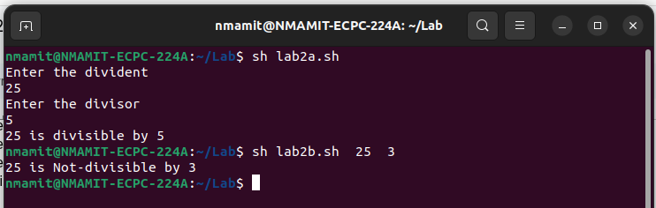

A2Divisible.sh Using Both CommandLine And Keyboard input

#!/bin/bash

if [ $# -eq 2 ]
then
n=$1
m=$2
else
echo "Enter the divident"
read n
echo "Enter the divisor"
read m
fi

y=`expr $n % $m`

if [ $y -eq 0 ]
then
echo "$n is divisible by $m"
else
echo "$n is NOT divisible by $m"
fi

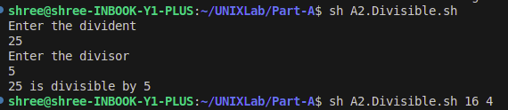

A3. Plan and implement a shell program to search a pattern in a file that will take both pattern and file name from the command line arguments.

A3.Pattern.sh
#!/bin/sh
if [ $# -eq 0 ]
then
echo "No arguments"
else
grep "$1" "$2"
fi

A3.Search.sh
#!/bin/sh
if [ $# -eq 0 ]
then
echo "Enter the pattern"
read pattern
echo "Enter the filename"
read filename
else
pattern=$1
filename=$2
fi
sh A3.Pattern.sh $pattern $filename

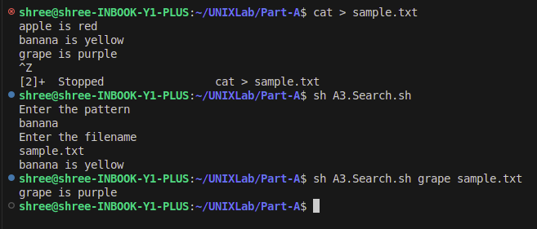

A4. Design a shell program that takes two file names, checks the permissions for these files are identical and if they are identical, output the common permissions; otherwise output each file name followed by its permissions.

A4.FilePermission.sh

#!/bin/sh
display_perm()
{
r=` ls -l $1 | cut -c 2 `
w=` ls -l $1 | cut -c 3 `
x=` ls -l $1 | cut -c 4 `
echo "Owner Permissions : "
if [ "$r" = "r" ]
then
echo "READ"
else
echo "NO READ"
fi
if [ "$w" = "w" ]
then
echo "WRITE"
else
echo "NO WRITE"
fi
if [ "$x" = "x" ]
then
echo "EXECUTE"
else
echo "NO EXECUTE"
fi
r=` ls -l $1 | cut -c 5 `
w=` ls -l $1 | cut -c 6 `
x=` ls -l $1 | cut -c 7 `
echo "Group Permissions : "
if [ "$r" = "r" ]
then
echo "READ"
else
echo "NO READ"
fi
if [ "$w" = "w" ]
then
echo "WRITE"
else
echo "NO WRITE"
fi
if [ "$x" = "x" ]
then
echo "EXECUTE"
else
echo "NO EXECUTE"
fi
r=` ls -l $1 | cut -c 8 `
w=` ls -l $1 | cut -c 9 `
x=` ls -l $1 | cut -c 10 `
echo "Others Permissions : "
if [ "$r" = "r" ]
then
echo "READ"
else
echo "NO READ"
fi
if [ "$w" = "w" ]
then
echo " WRITE"
else
echo "NO WRITE"
fi
if [ "$x" = "x" ]
then
echo "EXECUTE"
else
echo "NO EXECUTE"
fi
}

echo "Enter 2 valid filenames : "
read f1 f2
if [ -e "$f1" -a -e "$f2" ]
then
p1=` ls -l $f1 | cut -c 2-10 `
p2=` ls -l $f2 | cut -c 2-10 `
echo "$f1 : $p1"
echo "$f2 : $p2"
if [ "$p1" = "$p2" ]
then
echo "$f1 and $f2 have same Permissions"
display_perm $f1
else
echo "Permissions : for file $f1"
display_perm $f1
echo "Permissions : for file $f2"
display_perm $f2
fi
else
echo "Invalid filenames"
fi
exit

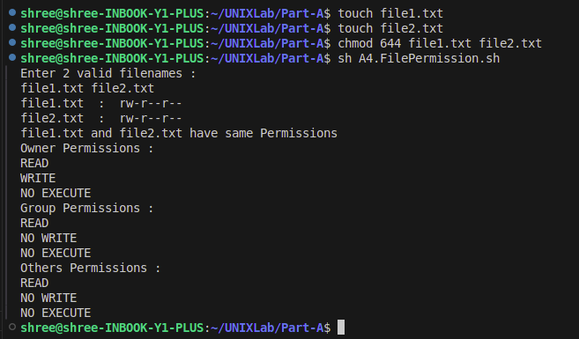

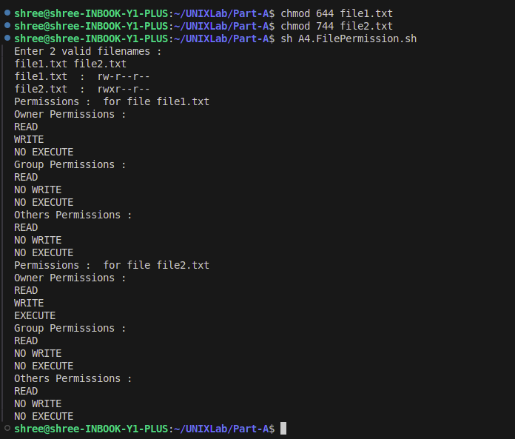

A5. Develop a shell script that performs following string handling operations
i) Calculate the length of the string
ii) Locate a position of a character in a string
iii) Extract last three characters from string
iv) Extract first three characters from the string

echo "Enter the String"
read string
if [ -z "$string" ]
then
echo "Null String"
else
z=` expr "$string" : ".*" `
echo "String Length is $z"
fi

if [ $z -ge 6 ]
then
z=` expr "$string" : "\(...\).*" `
echo "First 3 characters : $z"
x=` expr "$string" : ".*\(...\)" `
echo "Last 3 characters : $x"
fi

echo "Enter the character you need to search"
read a
location=` expr index "$string" "$a" `
if [ $location -eq 0 ]
then
echo "The $a not found in $string"
else
echo "The characters $a you were searching is in location $location"
fi

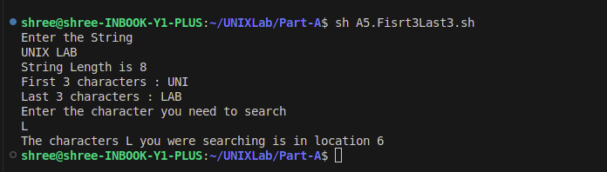

A6. Write a shell program to implement simple calculator operations.

A6.Calculator.sh

#!/bin/sh
echo "Enter two numbers:"
read a
read b
echo "Enter your choice:"
read ch

case $ch in
'+') y=`expr $a + $b`
echo "Result=$y"
;;
'-') y=`expr $a - $b`
echo "Result=$y"
;;
'*') y=`expr $a \* $b`
echo "Result=$y"
;;
'/') if [ $b -eq 0 ]
then
echo "Division is not possible"
else
y=`expr $a / $b`
echo "Result=$y"
fi
;;
*) echo "Invalid choice"
;;
esac

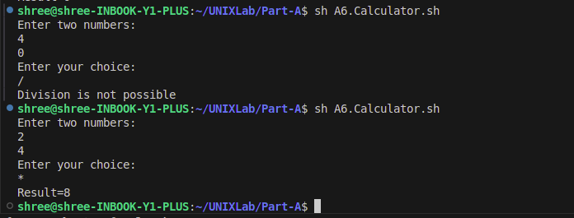
A7. Design a Shell Program that takes any number of arguments and prints them in the same order and in reverse order with suitable messages.

A7.ArgReverse.sh

#!/bin/sh
echo "Program name: $0"
if [ $# -eq 0 ]
then exit
Fi

echo "No of arguments: $#"
echo "The input arguments are : "
num=1
for i in "$@"
do
echo "arg$num is $i"
num=`expr $num + 1`
done

echo "Arguments in reverse order : "
num=$#
while [ $num -ne 0 ]
do
eval echo "arg$num is \$$num"
num=`expr $num - 1`
done

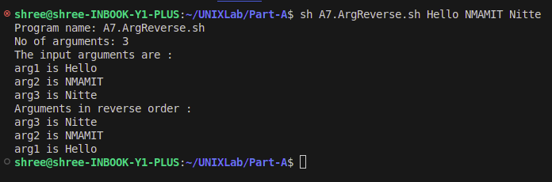

A8. For the given path names (E.g., a/b,a/b/c), design a shell script to create all the components in that path names as directories.

A8.CreateDir.sh

#!/bin/sh

if [ $# -ne 1 ]
then
echo "no arguments"
exit 1
fi

curdir=$(pwd)

for dir in $(echo "$1" | tr "/" " ")
do
if [ -d "$dir" ]
then
echo "$dir exists under $(pwd)"
cd "$dir"
else
mkdir "$dir"
echo "$dir created under $(pwd)"
cd "$dir"
fi
done

cd "$curdir"

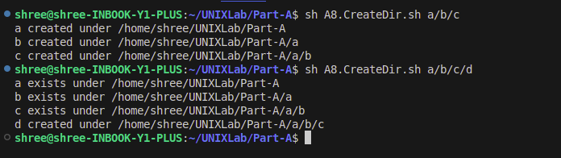

A9. For every filename, check whether a file exists in the current directory or not and then convert its name to uppercase only if a file with a new name doesn’t exist using shell script.

A9.UpperCase.sh

#!/bin/sh
for file in "$@"
do
if [ -f "$file" ]
then
upper=$(echo "$file" | tr '[a-z]' '[A-Z]')
if [ -f "$upper" ]
then
echo "$upper already exists"
else
mv "$file" "$upper"
echo "Renamed $file to $upper"
fi
else
echo "$file does not exist"
fi
done

